Safeguarding

At Park View Academy, all members of staff take Safeguarding very seriously. On this page you will find all the information you need to know about Safeguarding here at Park View.
Safeguarding Lead – Mr Damian Kenny– If you have any concerns about a child safety or welfare please come in and speak to the above named staff or if you feel you cannot wait and feel a child is at immediate risk please contact the Knowsley Access team on 443 2600.
Deputy Safeguarding Lead – Miss Debbie Walker
Safeguarding Governor – Our safeguarding link governor is Irene Tuzio.
Operation Encompass – There are currently no procedures for reporting Domestic Abuse incidents to schools which means that our children are left without the support and nurture that they need when they need it most. Operation Encompass has been created to address this so that by 9.00am on the next school day the school’s Key Adult will be informed that the child or young person has been involved, heard or witnessed a domestic incident. This knowledge, given to schools through Operation Encompass, allows the provision of immediate early intervention through silent or overt support dependent upon the needs and wishes of the child.
The key adults at Park View Academy are the Learning Mentor Miss Debbie Walker and Head teacher Damian Kenny.

E-Safety

What is E-safety?
E-safety is about the protection of children whilst they are using the internet and digital technologies. This includes: risk-taking and inappropriate behaviour by children and young people; risks and inappropriate behaviour by others to children and young people; illegal activity.
Cyberbullying
Online Grooming

Parents’ E-safety Survey
We would be really grateful if you could complete our e-safety survey. Whilst our school strives to empower your children with the knowledge to stay safe, it is important that you have a good awareness of the risks and dangers yourself.
To complete the Parents’ E-safety Survey please click on the link provided opposite.
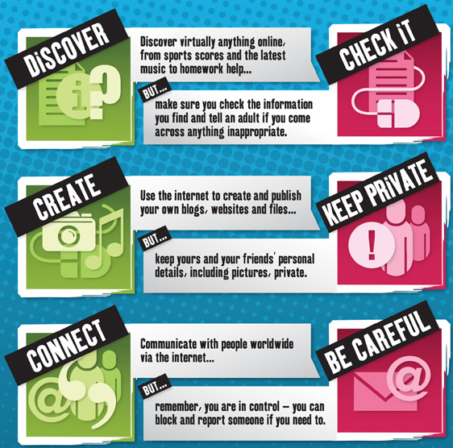

Cyberbullying….REPORT IT!
Cyberbullying is the use of Information Communication Technology (ICT), particularly mobile phones and the Internet to deliberately upset someone else.
1. Tell someone, report on Moodle using the ‘Report it’ tool on the homepage. Click on the REPORT IT! image below.
2. Save evidence and take screenshots.
3. Block the bully (on IM, social networking sites, etc.).
4. Don’t reply or retaliate to things they say or do.
5. Contact your mobile service provider (if bothered by txts, etc).

Child Exploitation and Online Protection Centre
For more information on internet safety please visit the CEOP website.

Where’s Klaus?
View the Where’s Klaus? video which focuses on e-safety.

Helpful Links
Download the Parents’ E-safety Leaflet
Download the Cyberbullying document

